- Introduction (global context, literature review, main questions and objectives)
- Technology and Literature Review
  - Android
Android is a mobile operating system (OS), developed by Google, Android is based on the Open Linux Kernel and designed for touch screen mobile and handheld devices. Furthermore, it utilizes a custom virtual machine, designed to optimize memory and hardware resources in a mobile environment. Android also allow developers to create mobile applications, take advantage of all mobile hardware. Application can call any of the phone's core functionality for example: making calls, sending text messages, or using the camera, allowing developers to create best experiences for users.
  - Open Street Map
OpenStreetMap is a world online map services and open contents. OpenStreetMap's purpose is providing geographic data collected from collaborated members around the world. Often called "Wikipedia of maps" with the inspiration of Wikipedia, a website allow collaborative modification its content and structure . The project OpenStreetMap, held in 2004, mainly to compete with other companies and government agencies which are providing geographic data under strict used terms.
In March 2012, the database contains information from more than 170,000 registered member. Members contribute data from the GPS receiver, or draw from the air with support application. They upload GPX route data and modified vector data using GIS programs for browsers, desktops, and mobile phones. In the big cities, local communities often hold "mapping party" for data collection . OSM is also constantly updated through helps of companies, government institutions that often send information of new locations or corrections of the existing ones. This allows the service to have more precise information of places around the world which can be a big advantage while google map focuses mainly big cities.
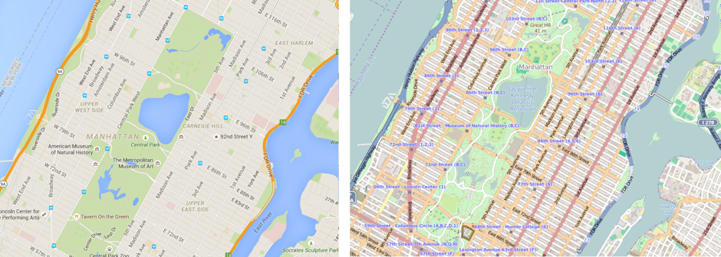
  - OSMDROID library
OSMDROID library is a Android library included tools and views to interact with OSM. It is a good alternative of Android Google Map tools. Osmrdroid helps users to build custom MapView, adding custom marker, polyline into Map View. Osmdorid using map tiles to display map. Map tiles are map pictures with different zoom levels. Osmdroid provides tools working with tile providers, loading tiles from offline storage or loading tiles from tiles server. Osmdroid assists offline and online mapping at the same time , loading missing map tiles of offline storage from tiles server for user full map experience. The library is easy to implement, with wide range of map tiles providers. However, tiles provides by osmdriod-supported providers are in normal quality.
  - Mobile atlas creator
Mobile Atlas Creator (MOBAC) is open source program provides offline map tiles for handheld or mobile phone application. Osmdroid offline map tiles could be created by MOBAC, using large number of online maps providers including OSM map provider ( MAPNIK, MAPQUEST ). Maps from MOBAC can be consisted of multiple layers and different map sources and map resolution. Map of specific location, location parameters, zoom level, can be created in user choice. Map could be downloaded using simultaneous multi-threaded download ( many tile can be downloaded at the same time) and downloaded tile cached locally to save time while file output could be very large.
Within the purpose of the project, project manager could created offline maps to assign exact location for each member. Member could download maps from server to locate whether they are in range of assigned location.
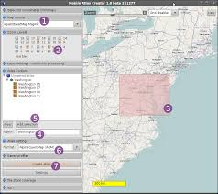
  - Geocoder
Geocoder is a class in the Android framework API. Geocoder provides a way to handle geocoding and reverse geocoding. Reverse coding is getting address of the location from coordinate (latitude, longtitude). Reverse geocoding information could not be exact location (may contain only city name or full street name of close by building).
For the application, mobile or handheld GPS receiver supply coordinates for Geocoder to get the exact address of the site, users tend to gather data. The address provide by Geocoder is for reference only, it could be change any time at the survey form.
  - Camera Class
The Camera class is managed to taking the picture, start/stop preview. It is a client for the Camera service, which manages the actual camera hardware. It provide only point and shoot, give no control of how the camera work.
This is suitable for the project 's intention, getting information only, not working with raw image capture.
  - AudioRecord
AudioRecord is a Android class to handle voice recording. The output can be raw audio signal, high quality raw audio file (PCIM). It can be easy implemented and converted into other audio file format (WAV by adding headers or other compressed audio file format MP3, `ACC, etc by wide range of support library). AudioRecord is used to create record of site information with high quality.
  - Json and Geojson
JSON , JavaScript Object Notation, a data format to follow a certain rule that most programming languages are readable. JSON can act as a record database. JSON format is simple and easier to use than other format ( XML).
JSON string is enclosed by braces {}. One object started by open bracket { and end with close braket }. followed by 2 dots mark: and the name / value separated by commas, The key is followed by the value by a colon : and they are put it in doubl quotes, single quote is not the correct standard JSON string. If there are more data comma use to separate between two objects.
JSON format example
{
{"firstName":"John", "lastName":"Doe"},
{"firstName":"Anna", "lastName":"Smith"},
{"firstName":"Peter", "lastName":"Jones"}
}
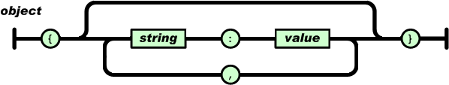
One array is one set of values, One array started by open tag [ and ends with the closing tag ]. The values are separated by commas.
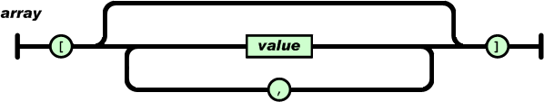
JSON Array Example:
{"employees":[
{"firstName":"John", "lastName":"Doe"},
{"firstName":"Anna", "lastName":"Smith"},
{"firstName":"Peter", "lastName":"Jones"}
]}

One value can be one string in double quotes, or one number, or true or false or null, or is 1 object or 1 arrays. These structures could be nesting.
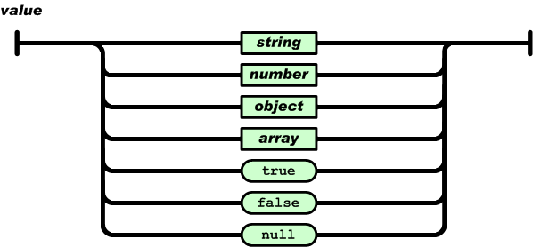
  - GeoJSON
GeoJSON is a format for encoding geographic data structures. Basically GeoJson follow format but it has their specific key (type, geometry, properties). Type could be Feature geojson object (location) or can be Feature Collection geojson array (locations) which contain of Feature type geojson object. Geometry key is position of the data (Point, MultiPoint, LineString, Polygon, etc). Properties is a json object where user can freely add needed information of the location. The survey form is saved into geojson format.
GeoJson Example:
{ "type": "FeatureCollection",
"features": [
{ "type": "Feature",
"geometry": {"type": "Point", "coordinates": [102.0, 0.5]},
"properties": {"prop0": "value0"}
},
{ "type": "Feature",
"geometry": {type": "LineString", "coordinates": [[102.0, 0.0], [103.0, 1.0], [104.0, 0.0], [105.0, 1.0]
},
"properties": { "prop0": "value0",
"prop1": 0.0}
}
]
}

  - FTP
FTP is short for File Transfer Protocol. A protocol is a set of rules that networked computers use to talk to one another. FTP is the language that computers on a TCP/IP network (internet) use to transfer files to and from each other. The FTP server may support Active and Passive connections. In an Active FTP connection, the client opens a port and listens and the server actively connects to it. In a Passive FTP connection, the server opens a port and listens and the client connects to server through port.
- UI Design
  - First UI Prototype
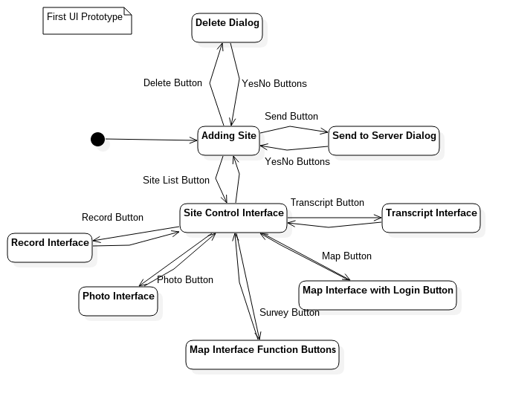
  - Second UI Prototype
Change from the first prototype:
Adding introduction wizards and team information interface.
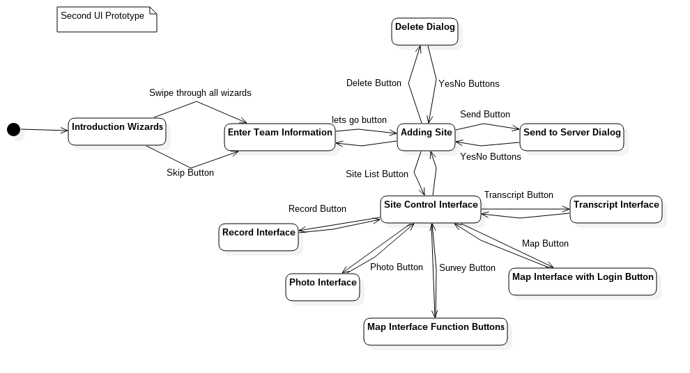
  - Third UI Prototype
Change from the second prototype:
New UI approach: better user experience, save time for user to do all the data collecting task.
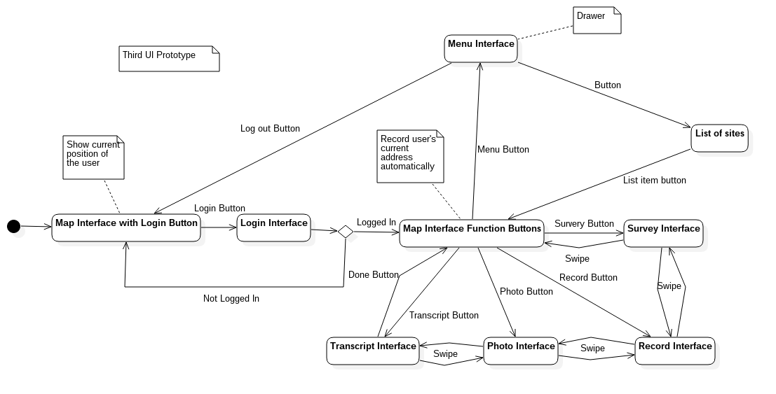
- Analysis
  - Use Case Diagram
Use Case diagrams are valuable:
Identify the clients expectations for the system.
Identify specific features of the system.
Identify shared behavior among system features.
Provide a simple and easily understood way for clients to view their requirements
  - Map Interface
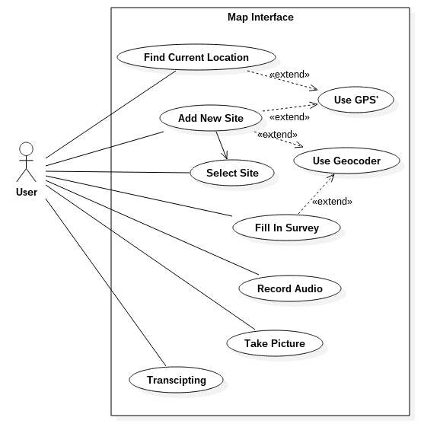
  - Recording Audio
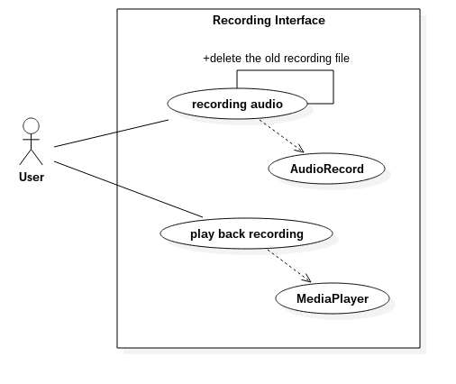
  - Taking Picture
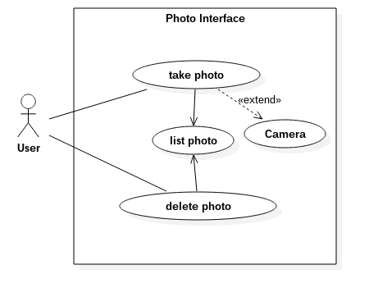
  - Fill in Survey
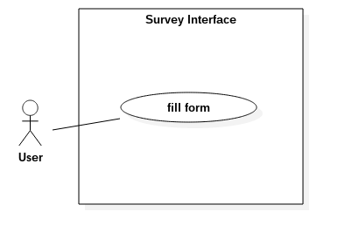
  - Taking Transcript
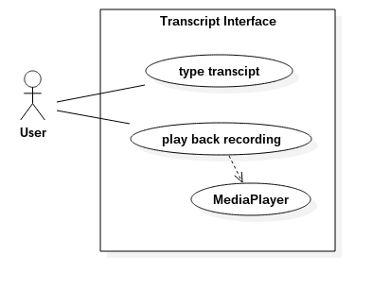
  - List of Site
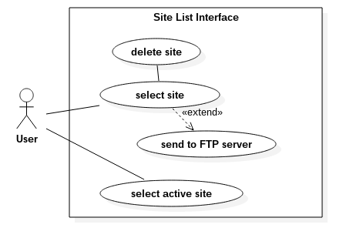
- Screen Shots
  - Map Interface
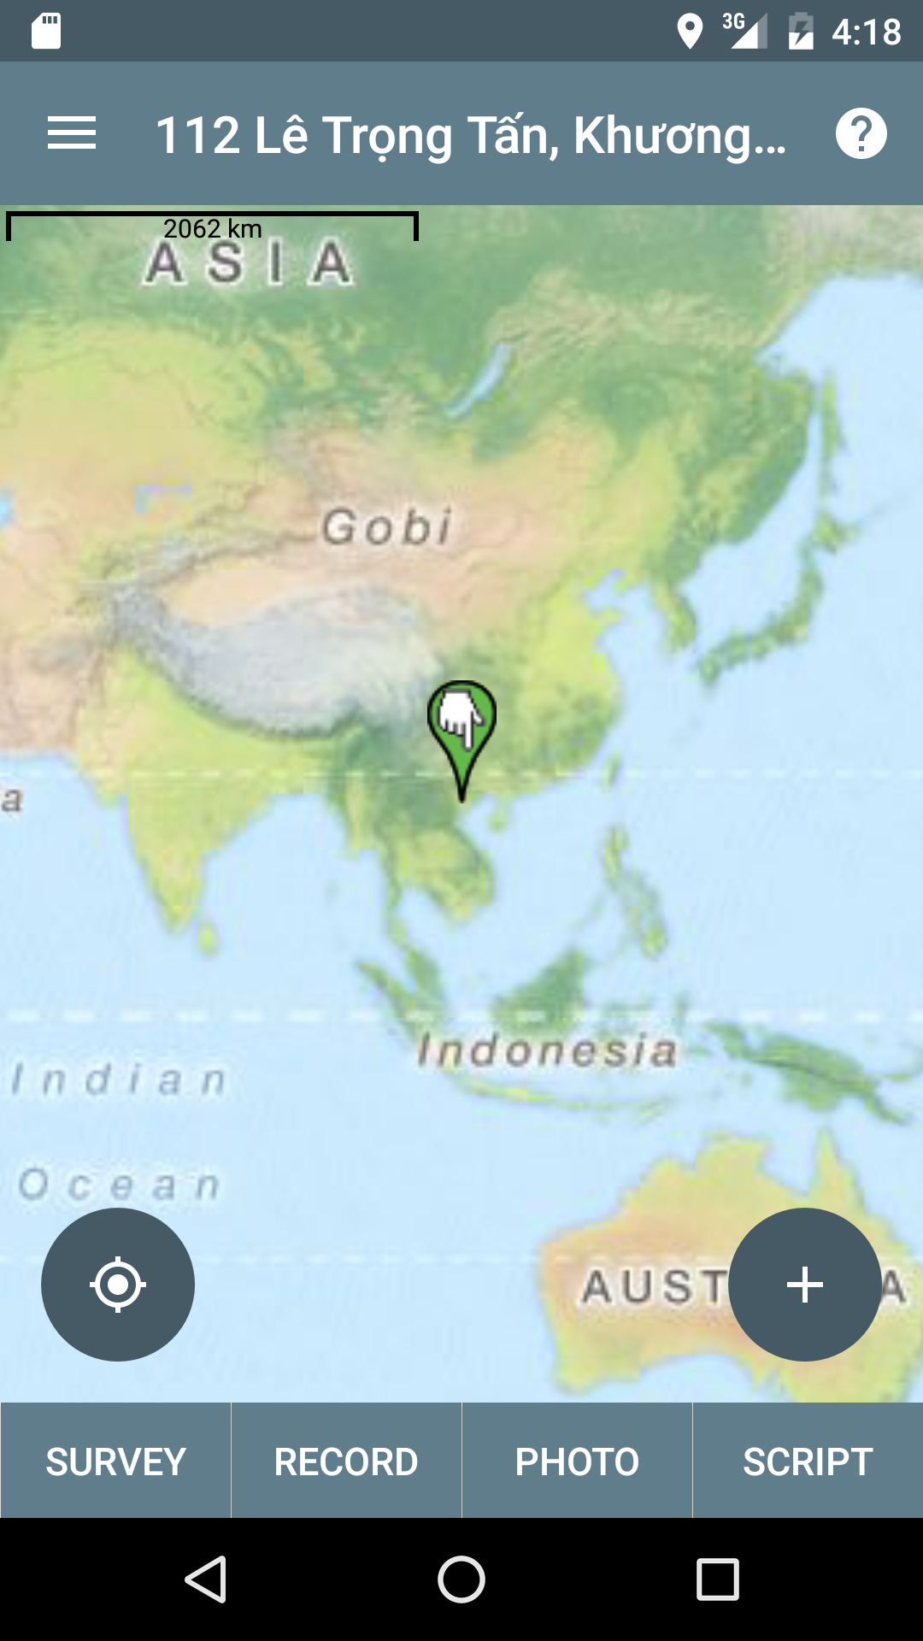
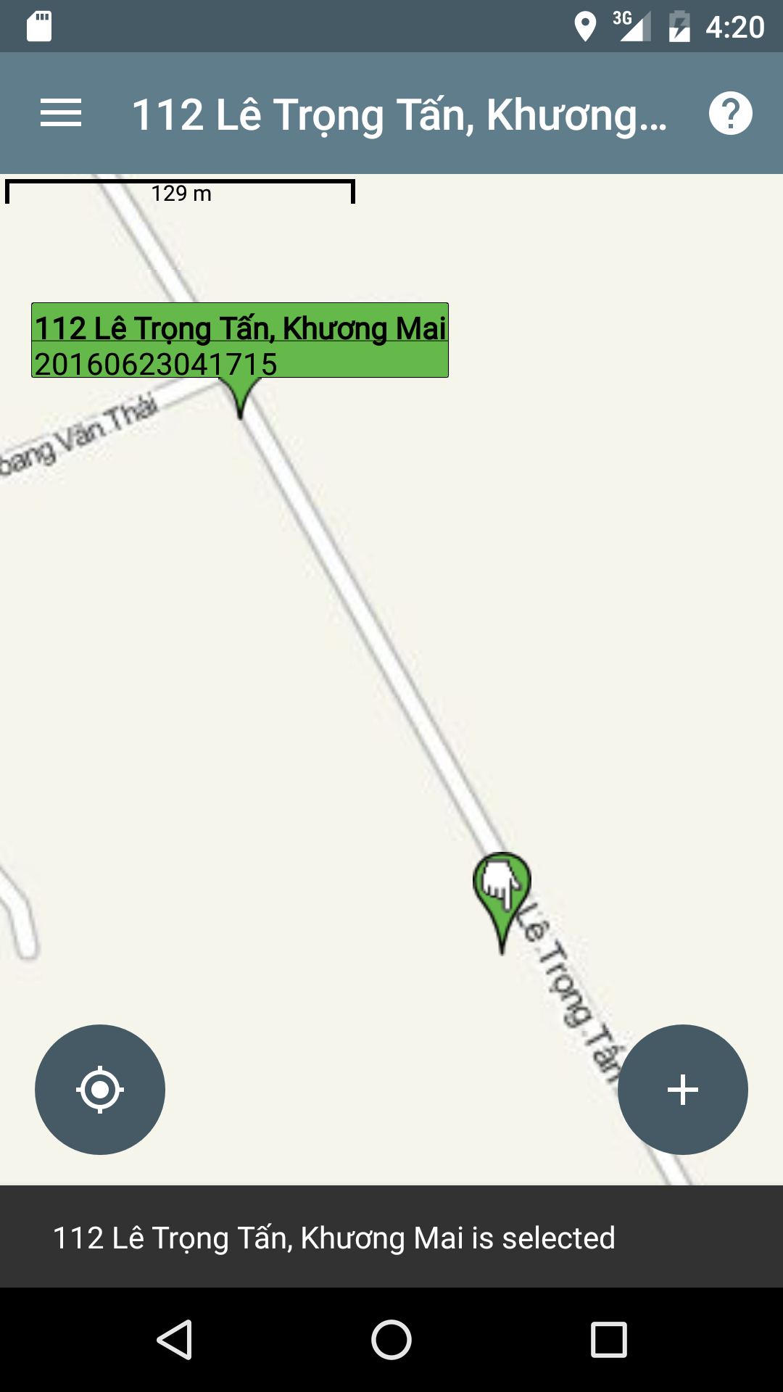

The world map appears, user need some times to wait for GPS tracking the current location then the user could use find current location button locate on the left of the screen, or the add new site button located on the right side of the screen. The map shows all the sites which have been recorded by the user. Select at location user want to change data or add more data.
  - Survey Interface
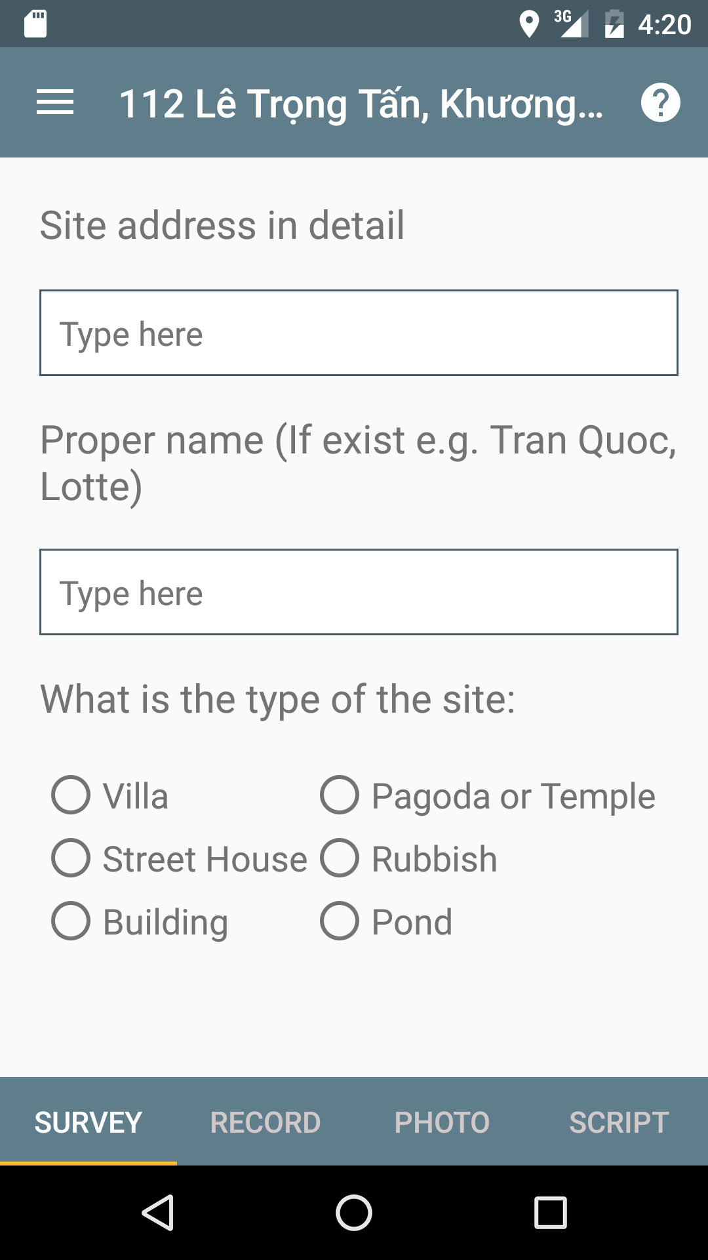
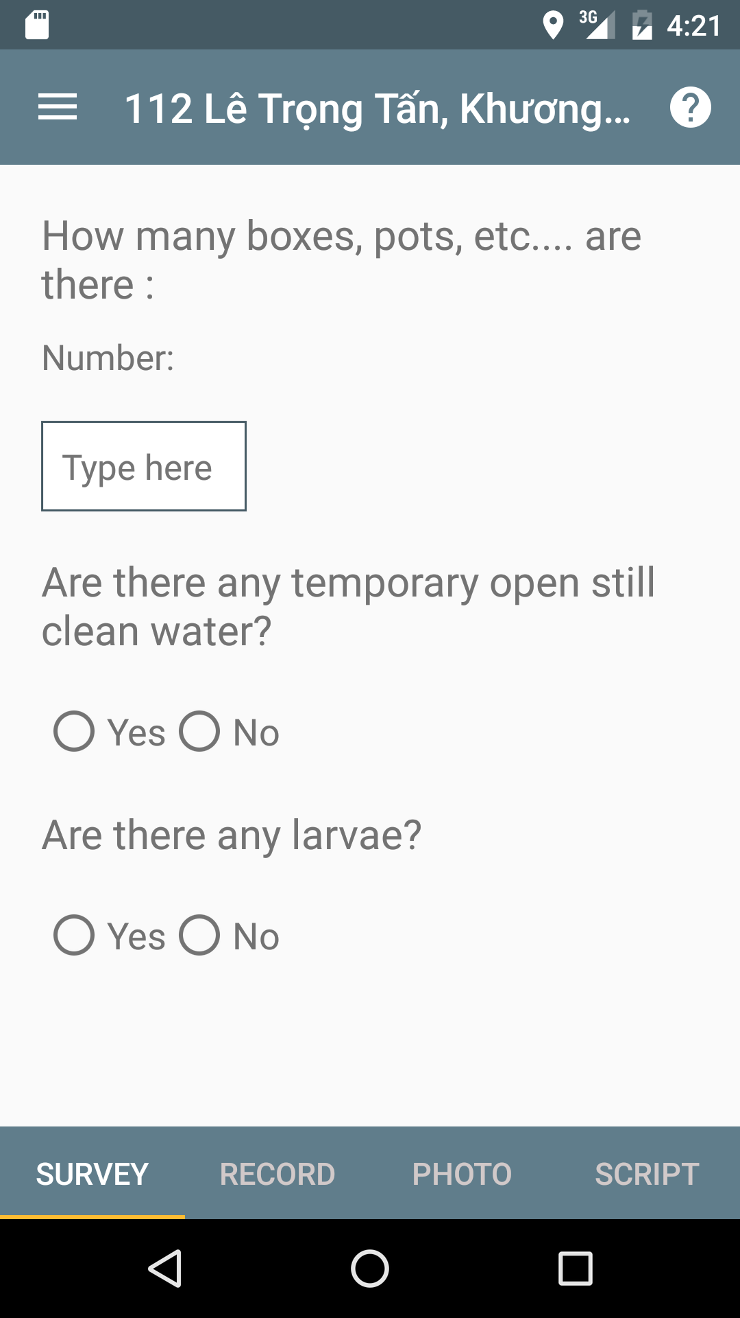
  - Record Interface
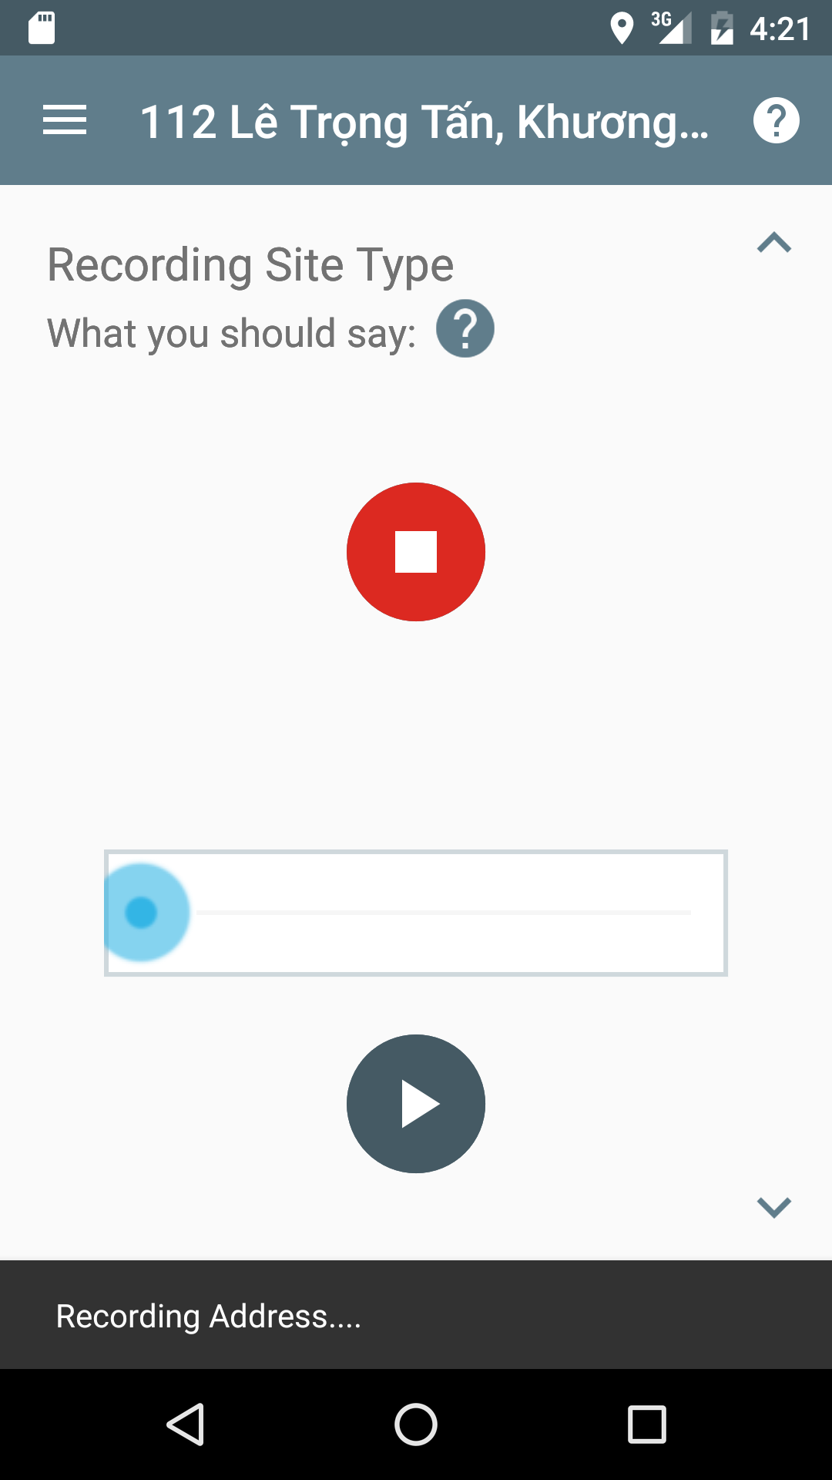
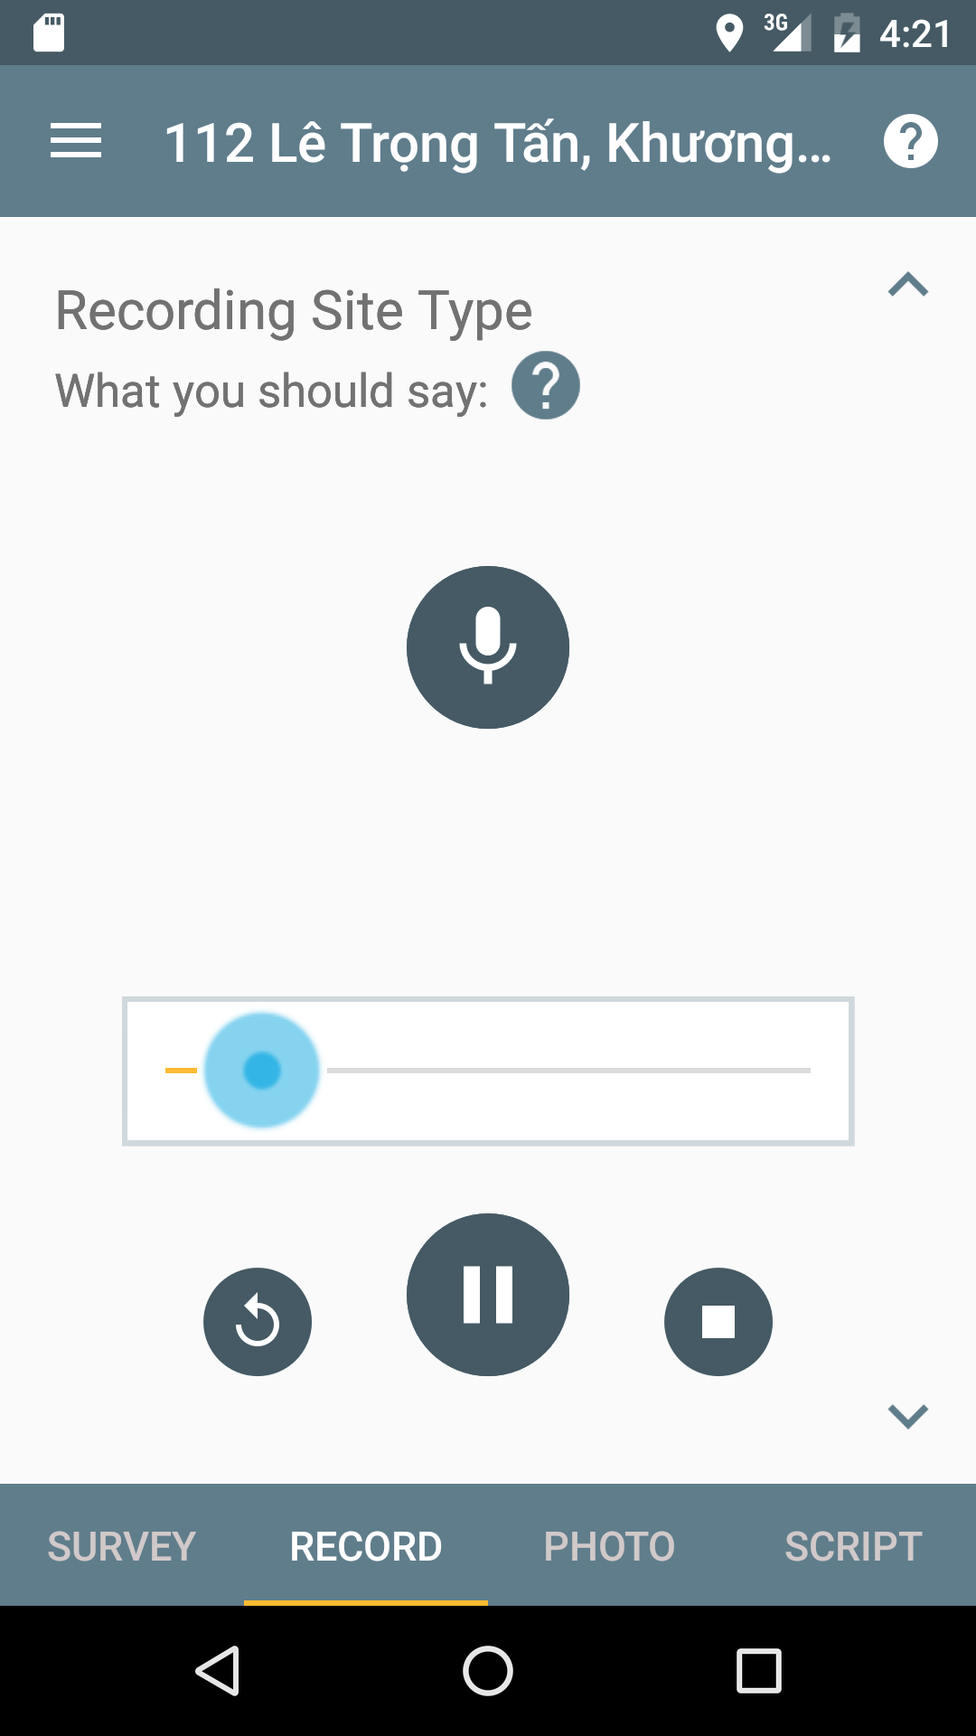
  - Photo Interface
  - Transcript Interface
  - Site List Interface
- Discussion and Conclusion
- References
- Appendices/Annex

